Staying Connected

TreSports
October 2020 Edition

October 2020 New

A Message for the President
TreSports is a non-profit (501c3) organization dedicated to building character, confidence, and sportsmanship in children. In 2002 I began TreSports to address a need for a program that focused on the total development of the student-athlete. To this end, the foundation of our organization was designed from a holistic approach that incorporates scholarship, community service, character development and athletic excellence through competitive sports.
TreSports has created a blueprint for youth to reach their goals through academic programs, mentorship and athletics. Today, we assist approximately 350 youth between the ages of 5 -18
years old with academic supports and player development in football, basketball, cheerleading and other related programs.
TreSports is thriving with approximately 30 students between the ages of 11-18 years old who are currently enrolled in programs. The students attend 15 Charlotte Mecklenburg Middle & High Schools. Our philosophy is to guide students to make positive and productive decisions through best practice and evidenced based models that foster self- awareness, self-confidence and character development that encourages improved school participation, attendance and academic performance.

TreSports COVID-19
Policy and Procedures

- If you are feeling sick or have a temperature prior to coming to TreSports, PLEASE STAY HOME!!
  - If you begin feeling sick during the day while at TreSports, please inform our staff immediately.

- ALL Staff temperatures MUST be checked before entering the building each day.
  - All temperatures must be between 97°F - 99°F.
    - If temperatures are 102°F or higher, staff will be asked to return home.

  - All students’ temperatures MUST be checked at van pick-up.
    - If temperatures are 102°F or higher, students will be asked to return home.

  - If there are outside activities or field trips, all temperatures must be checked 20 mins after returning back in the building.

- MUST wash hands for 20 seconds.
  - After the student completes the temperature check, the student will be asked to wash their hands before entering the classroom.
    - Front and back of all students’ hands must be washed in male or female bathrooms.

- MUST wear a mask……
  - While on field trips, masks MUST be worn at all.
    - During van rides, masks must be worn.
    - At field trip destinations, masks must be worn.
  - Masks are not required to be worn for outside activities at TreSports.

- MUST use hand sanitizer before entering and exiting the van.
  - Each student must use hand sanitizer before getting on the vans.
  - Each student must use hand sanitizer before exiting the van on field trips.

- MUST be 6ft apart inside the building at all times.
  - All desk and chairs have been measured for social distancing therefore all students will be spaced 6ft apart.

- NO sharing of objects.
  - Each child will have their own workstation utensils in Ziplock bags with their names labelled on them.
    - Utensils include: pencil, pens, composition notebook, journal notebook, markers, glue, and scissors.

- MUST wear gloves while serving food and snacks.
  - Staff will be wearing serving gloves at all times while serving each student their food trays and drinks at their seats.
  - Lunch serving gloves will be disposed of once lunch has been served.
  - Staff will be wearing serving gloves at all times while serving each student their afternoon snack and juice at their seats.
  - Snack time serving gloves will be disposed of after snacks have been served.

- MUST clean the classroom after each day.
  - Students will be asked to wipe down their work areas at the end of each day.
  - After students dismiss from the classroom, staff will also clean the building each day before leaving the building.

Spring Session 2020

What Effects Have COVID-19 Had on
TreSports Business Operations?

Since COVID-19 has hit Mecklenburg County in March of 2020, it has forced agencies to alter their face-to- face daily operations and implement virtual strategies. TreSports like most agencies and schools was also forced to alter our program operations for our 2020 Spring Session, which was held via Zoom. TreSports had a successful class of 13 students that graduated from the program on May 5th.

Summer Session 2020

As North Carolina entered Phase 2 in the earlier part of June, TreSports was able to have an in-person Summer Session. With Phase 2, we were only able to open up to 50% capacity, therefore our summer session included 15 students. During the summer, the students were taught the Positive Action curriculum. The Positive Action curriculum focuses on thoughts, feelings and actions. The curriculum also has an emphasis on positive ways to express yourself and self awareness. Students worked hard in the classroom on skill building and working in teams. Teachers discussed topics around goal setting and the importance of having a plan for your life. The kids worked diligently creating vision boards for themselves and presenting them to the class. There were aspiring NFL players, doctors, lawyers, and successful entrepreneurs. After envisioning the future for themselves, students learned how to set realistic and attainable goals..

During the summer the students were able to participate in a variety of field trips such as bowling, college tours to JC Smith and UNC-Charlotte, Nascar Speed park, as well as have events at TreSports such as Mad Science and the Video Game Truck. In all, 15 students graduated the program with outstanding test results and participation.

Fall Session 2020

Still operating under Phase 2, TreSports has begun it’s 2020 Fall Session on September 8th with 50% of the student capacity due to COVID guidelines for students to maintain 6ft distancing. As of today, the students are on task and have grasped the Positive Action curriculum. What they have learned so far has been:

What is Life’s Biggest Question?
Who Am I?
TreSports Positive Action Philosophy
Tiers and Sub-Tiers
Triggers/Cues/Reminder
Conflict Resolution and how to solve them using the STABEN method

In addition to our Positive Action curriculum, we are excited to be partnering again with former Judge and Attorney Ms. Bahiyyah A. Walker, J.D for her program called Weighing in with Walker.

Weighing in with Walker is a program that is taught to educate the students about the ignorance of criminal law and criminal procedures, depressed critical thinking skills, suppressed personal and academic aspirations, and underdeveloped and unarticulated self-identity. The students are especially excited about the program because it allows them to see the laws and its procedures in the eyes of government officials and better understand the actions of the court system as it pertains to juveniles.

Also, we had the pleasure to have a guest speaker who came to speak with the students about his program called Behind Prison Walls. This program was presented to us by a former C.O from Rikers Island by the name of Mr. Lorenzo Steele. His program is designed to help youth understand the reality of living Behind Prison Walls. He spoke with the youth as well as brought visual arts and props to provide a better visual perspective on the reality of living in prison. His presentation really caught the students interest and attention. It provided an insight of the daily life of prisoners and how some fight to survive every day.
Parents Corner

pARENT’S CORNER

TreSports also has a section of its program that supports the parents of TreSports students via a curriculum called Parenting Wisely. Parenting Wisely is a support group for parents that have children participating in the TreSports program. It is designed to help teach parents skills and techniques to help better understand their children. Parenting Wisely focuses on increasing the empathy and communication among all members of the family. The program points out, in a non-blaming manner, how a parent’s current parenting practices may be a contribution to their family’s problems, and then demonstrates proper parenting techniques which have been shown to improve family relationships and well as children’s problem behaviors.

We were able to host our first Parenting Wisely Session on September 30th via Zoom. We had 85% participation from the parents of TreSports students. Because it was our first meeting, we started off with introductions, icebreakers, and an explanation of the Parenting Wisely curriculum and its purpose. We also chose discussion topics that dealt with areas in our lives that could help support and encourage one another their and ways to parent effectively.

TRESPORTS
UPCOMING EVENTS

VOTING

Here at TreSports, we will want everyone to do their duty and exercise their right to vote. It is most important to have your voice heard because voting is one of the most impactful things you can do for yourself and your community. It’s easy to think that you’re just one person and that your vote doesn’t make much of a difference, but it does.

5 Reasons Why You Should Vote:

1. Elections have consequences.
You have the power to decide on the quality of life you want for yourself and future generations. Voting is your chance to stand up for the issues you care about like public transportation, raising minimum wage, or funding local schools. This is your life: take the time to help decide what’s best.

2. Not voting is giving up your voice.
Elections are decided by the people who go out and vote. Take some time and learn about the measures and the candidates. If you don’t vote, someone else will make the decision for you. Your power is in your vote.

3. It's your money.
You pay taxes, but do you know how that money is being used? Most people don’t. Voting is your chance to choose how your tax dollars are spent – such as funding for health care and social services.

4. Voting is an opportunity for change.
Do you want to make a positive impact? Voting gives you that chance! Support the candidates and ballot measures that can help your community, state, and even the nation for the greater good. Make your voice heard in these elections.

5. The community depends on you!
Our communities are made up of friends, loved ones, neighbors, and children. Some may not know how important voting is, while others don’t have the privilege. Make the decision to vote for yourself and those around you.
Make sure your voice is heard, VOTE!

Here is additional information to you need to know about this year’s Election Day:

Election Day is November 3rd

Early voting runs from October 15th through October 31st

The offices on the 2020 ballots are:

President and Vice President (4 Years)
Senate (6 years)
1 Seat
U.S. House of Representatives (2 Years)
9th Congressional District; 12th Congressional District
*Pending all litigation

Governor (4 Years)
Council of State (4 Years)
Lieutenant Governor
Attorney General
State Auditor
Commissioner of Agriculture
Commissioner of Insurance
Commissioner of Labor
Secretary of State
State Treasurer
Superintendent of Public Instruction
State Treasurer

Make your voice be heard…... GO VOTE!!!

THANKSGIVING DRIVE

“FEED A FAMILY”

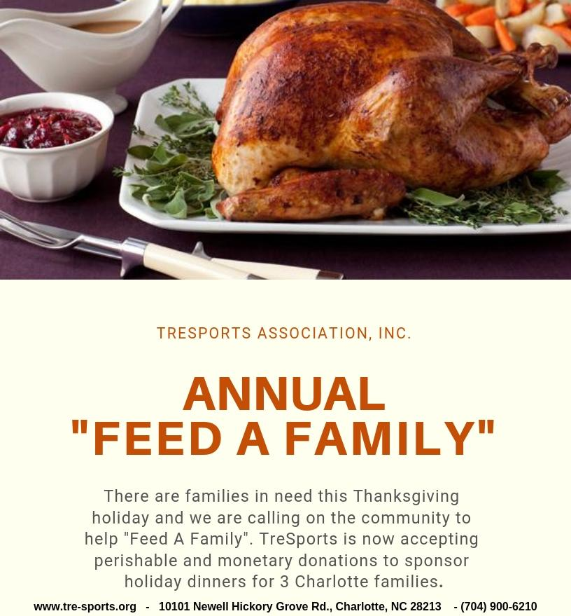
Donations will be accepted November 1st through November 22nd

ACCEPTABLE DONATION ITEMS
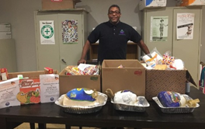
Turkey
Mashed Potatoes and Gravy
Collard Greens
String Beans
Sweet Potatoes
Cranberries
Stuffing/Dressing
Macaroni and Cheese
Dinner Rolls/Cornbread
Paper Plates & Plastic Cutlery
Aluminum Tins
Disposable Serving Dishes
Pies and Cakes are acceptable too

TRESPORTS
TOYS-4-TOTS GIVEAWAY

Where: TreSports Building
Date & Time: TBA

